**Experiment: 3.1**

**Student Name:** SANJIV GUPTA **UID:** 21BCS-*3478*

**Branch:** CSE **Section/Group:** 21BCS-IOT-602B

**Semester:** 5th **Date:** 26/10/23

**Subject Name**: AIML Lab **Subject Code:** 21CSH-316

1. **AIM:** *Write a python program to compute Mean, Median, Mode, Variance and Standard Deviation using Datasets*
2. **Objective:**

*The objective of this experiment is to evaluate the performance of an algorithm.*

1. **Tools/Resource Used:**

*1. Python programming language.*

*2. Jupyter Notebook.*

1. **Algorithm:**

* *input: A list of data points, data.*
* *Import the statistics module*
* *Define a function compute_statistics(data):*
* *Calculate the mean of the data using statistics.mean and store it in the variable mean.*
* *Calculate the median of the data using statistics.median and store it in the variable median.*
* *Calculate the mode of the data using statistics.mode and store it in the variable mode.*
* *Calculate the variance of the data using statistics.variance and store it in the variable variance.*
* *Calculate the standard deviation of the data using statistics.stdev and store it in the variable std_deviation.*
* *Return mean, median, mode, variance, and std_deviation.*
* *Define a sample dataset data as a list of integers.*
* *Call the compute_statistics function with the sample dataset data as an argument, and store the results in the variables mean, median, mode, variance, and std_deviation.*
* *Print the results:*
* *Print "Dataset: " followed by the data list.*
* *Print "Mean: " followed by the mean value.*
* *Print "Median: " followed by the median value.*
* *Print "Mode: " followed by the mode value.*
* *Print "Variance: " followed by the variance value.*
* *Print "Standard Deviation: " followed by the std_deviation value.*
* *End of the algorithm.*

1. **Program Code:**

*import statistics*

*def compute_statistics(data):*

*mean = statistics.mean(data)*

*median = statistics.median(data)*

*mode = statistics.mode(data)*

*variance = statistics.variance(data)*

*std_deviation = statistics.stdev(data)*

*return mean, median, mode, variance, std_deviation*

*# Sample dataset*

*data = [4, 2, 7, 1, 9, 6, 3, 6, 8, 5]*

*mean, median, mode, variance, std_deviation = compute_statistics(data)*

*print("Dataset: ", data)*

*print("Mean: ", mean)*

*print("Median: ", median)*

*print("Mode: ", mode)*

*print("Variance: ", variance)*

*print("Standard Deviation: ", std_deviation)*

1. **Output/Result:**

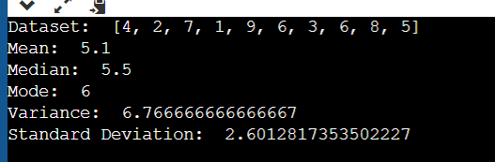

1. **Learning Outcomes:**
2. *Implement to implement different python library.*
3. *Understand the concept of mean,median etc.*